**Installing Elastic search and Kibana in a AWS EC2 Instance**

**Prerequisites**

1. An AWS EC2 instance preferably t2.medium
2. An elastic Ip assigned
3. Security group added for Elastic search with port no.9200 and for Kibana with port no.5601

We use putty to connect with the instance and installation is done by commands through Putty.

Setting up Elastic search and kibana in an EC 2 instance will be of three parts :

**1.Installing Java**

For installing elastic search in an Ec2 instance we require java to be installed.

Java installation can be done by the following steps:

Install Java latest version by the following command

sudo amazon-linux-extras install java-openjdk11

You can verify whether java is properly installed or not by the following command

java -version

This command will give you the version of the Java package installed.

Export the path of the installed Java package by the following command:

export JAVA_HOME=/usr/lib/jvm/java-11-openjdk-11.0.13.0.8-1.amzn2.0.3.x86_64/

Now we can proceed with installing Elastic Search.

**2.Installing Elastic Search**

Next is installing Elastic Search in Amazon Linux EC2 instance.

For that we need to run the following command first to accept the GPG keys for elastic search.

sudo rpm --import <https://artifacts.elastic.co/GPG-KEY-elasticsearch>

Now we have to create a new file with name elasticsearch.repo

sudo nano /etc/yum.repos.d/elasticsearch.repo

We have to add the following lines to the created file elasticsearch.repo

[elasticsearch]

name=Elasticsearch repository for 7.x packages

baseurl=https://artifacts.elastic.co/packages/7.x/yum

gpgcheck=1

gpgkey=https://artifacts.elastic.co/GPG-KEY-elasticsearch

enabled=0

autorefresh=1

type=rpm-md

Save the file elasticsearch.repo and exit.

Next step is to install the elastic search by running the following command.

sudo yum install --enablerepo=elasticsearch elasticsearch

Then we have to enable elasticsearch.

sudo /bin/systemctl enable elasticsearch.service

After that , we have to start the elastic search by the following command.

sudo systemctl start elasticsearch

Now that we have started the elastic search we need to check whether it is working or

not.For that we use the command

sudo systemctl status elasticsearch

We will get a Active Running status for this command.This denotes that the Elastic search is

successfully installed in our AWS Ec2 instance.

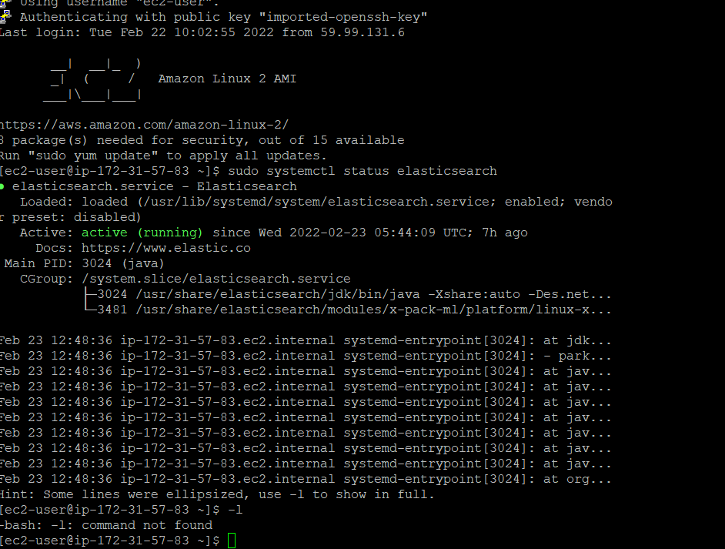

Next part is to configure the elastic search installed by changing the network host in the

elasticsearch.yml. So to open the file we have to run the following command.

sudo nano /etc/elasticsearch/elasticsearch.yml

Now we have to edit this file.

Uncomment the line Cluster.name: my-application

Network.host: 0.0.0.0

Uncomment the line Cluster.initial_master_nodes: [“node1”,”node2”]

Save and exit the file. And then restart the elastic search.

sudo systemctl restart elasticsearch

To check the output of elastic search run the below curl command.

curl -X GET "localhost:9200/"

This will display the details of our elastic search cluster including version in the command line.

To view the output in browser we need to type the following in the address bar

<public-ip-of-the-instance>:9200

This displays the cluster details in the browser.

**3.Installing Kibana**

Next part is to install Kibana by running the following commands:

wget <https://artifacts.elastic.co/downloads/kibana/kibana-7.15.2-x86_64.rpm>

sudo rpm --install kibana-7.15.2-x86_64.rpm

After installing we have to enable kibana by running the following command

sudo systemctl enable kibana

Then we have to start Kibana and then will check for the status of Kibana.

sudo systemctl start kibana

sudo systemctl status kibana

The above command will display an active running status for kibana which denotes that we

have installed the kibana succesfully.

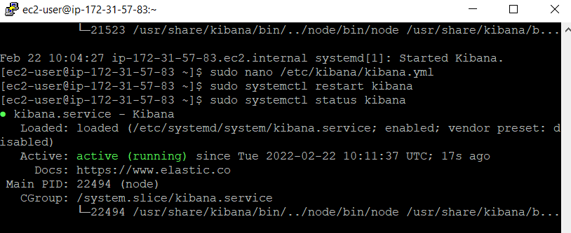

Now we have to configure our Kibana.for that we need to open the file Kibana.yml

In this file the server port is 5601

Uncomment the line server.host and add Ip as 0.0.0.0. Save the file and exit.

Restart the kibana and check the status.

sudo systemctl restart kibana

sudo systemctl status kibana

Now we have to access kibana in browser.we need to type the following in the address bar

<public-ip-of-the-instance>:9200

This will direct you to elastic site. You can search for console and access Kibana.